Name: _______________________ Class: __________ Date: _______
Instructions: Write answers in the right-hand column. Score: ___________ / 78 marks

Section A—Multiple choice (18 marks)

Write correct answer
below ….
All living plants and animals in a particular region may be described as:
A a community B an organism
C the environment D an ecosystem.

A ‘biome’ refers to:
A a chemical pollutant
B an artificial environment such as a greenhouse
C areas having similar climatic conditions
D a biogeographical region.

A habitat is:
A the most specific level possible for an organism’s address
B the broadest category for an organism’s address
C an organism’s typical behaviour
D a specific area such as a sand dune or tree.

Physical characteristics or behaviours that help an organism live in a particular environment are called:
A attributes B adaptations C camouflage D instincts.

Which of the following is an abiotic factor that influences where an organism can live?
A humidity B predation
C human intervention D competition from other organisms.

Salinity is a measure of:
A the number of organisms in a particular region
B the acidity of soil
C the amount of water vapour in the air
D the salt content of water.

The original source of all energy used by organisms is:
A plants B water C glucose D the Sun.

A secondary consumer is:
A a plant
B an animal that eats plants
C an animal that eats an animal that eats plants
D an omnivore.

Each link in a food chain is:
A a plant B an animal C an organism D a carnivore.

Communities with high biodiversity are more likely to survive environmental changes because they:
A contain more than one type of food source for the organisms within them
B have denser plant growth, which insulates the community from such changes
C are generally popular tourist attractions and are protected by law
D consist of large numbers of only a few species.

The number of producers in a food chain is:
A less than the number of producers
B the same as the number of consumers
C greater than the number of consumers
D possibly any of the above, depending on the organisms involved.

A decomposer is:
A an animal that eats another animal
B a plant that loses its leaves in winter
C an organism that breaks down organic matter so it is recycled
D an animal that uses sound as its main method of communication.

The pH of pure water is:
A 0 B 3 C 7 D 10

The interaction between a remora (a type of sucker fish) and a shark to which it attaches, is an example of commensalism because:
A the remora benefits, but the shark is harmed
B the remora benefits, but the shark is unaffected
C the remora is unaffected, but the shark is harmed
D both fish benefit from their relationship.

The impact of humans on the ecosystem increased suddenly after the:
A environmental convolution B mechanical inspiration
C climatic illusion D industrial revolution.

A pollutant is:
A a substance created by human activity that harms the environment
B a natural or artificial substance that makes the environment unhealthy for some organisms
C a gas such as sulfur dioxide that is able to reach the atmosphere
D something produced when a fossil fuel is burnt.

The greenhouse effect occurs because gases released into the atmosphere cause:
A plants to grow too quickly and rob the atmosphere of vital gases
B heat to be trapped on Earth
C the hole in the ozone layer to increase in size
D the atmosphere to become too thin and allow more energy to escape from the Earth.

Which of the following are introduced species as far as Australia is concerned? (There may be one or more answer.)
A hairy-nosed wombat B carp
C pig D rabbit

Frogs in Australia are considered to be environmental indicators because:
A they are the most common Australian animal and so may be easily caught and studied
B they are at the bottom of the food chain
C they breathe through their skin and depend on water, so pollutants tend to affect them strongly
D they change colour in response to pollutants.

Section B—Written answers (60 marks)

Place in order from smallest to largest.
biome
microhabitat
biosphere
habitat
biogeographical region

Match each of the following with one of the regions given in the previous question.
a just under the surface of some desert sand biome
b the part of our planet where life exists microhabitat
c grassland biosphere
d a tussock of grass biogeographical region
e Australia habitat

Give two examples of:
a organisms
- ___________________________
- ___________________________

b the non-living environment.
_______________________________
_______________________________

What characteristics might you find in an organism that lives most of its life under the desert sand?
_______________________________________________________
_______________________________________________________
_______________________________________________________

a Choose an animal and describe two physical adaptations.
Animal __________________________________
Two Physical Adaptations
_____________________________________________
_____________________________________________

b Choose another animal and describe two behavioural adaptations.
Animal __________________________________
Two Behavioural Adaptations
_____________________________________________
_____________________________________________

What scale measures acidity?
_____________________________________-
The pH of five chemicals are shown below:
3, 6, 7, 9, 13
Which of these numbers best represents:
a a weak acid ____________________________
b pure water ____________________________
c a strong acid _____________________________
d a weakly alkaline solution _____________________
e a strong base or strongly alkaline solution? ____________________

Give a specific example of how each of the following affect organisms.

a temperature
_________________________________________________________________
_________________________________________________________________
b humidity\
_________________________________________________________________
_________________________________________________________________
c light availability
_________________________________________________________________
_________________________________________________________________
d acidity
_________________________________________________________________
_________________________________________________________________

Clarify each of the following factors that effect where an organism can live.

a competition
________________________________________________________________________________________________________________________________________________
b dispersal
________________________________________________________________________________________________________________________________________________

c predation
________________________________________________________________________________________________________________________________________________

d human intervention
________________________________________________________________________________________________________________________________________________

State a biotic factor and an abiotic factor (in that order) that may affect a kookaburra.

Biotic Factor Abiotic Factor
_________________________________ _____________________________________
_________________________________ ______________________________________
_________________________________ _____________________________________
_________________________________ ______________________________________

Classify each of the following as a herbivore, carnivore or omnivore.
a crocodile _________________________________________
b deer _________________________________________
c blue-tongue lizard _________________________________________

Draw a diagram showing links between the following animals in a possible food chain.
snake
garden skink
kookaburra
fly

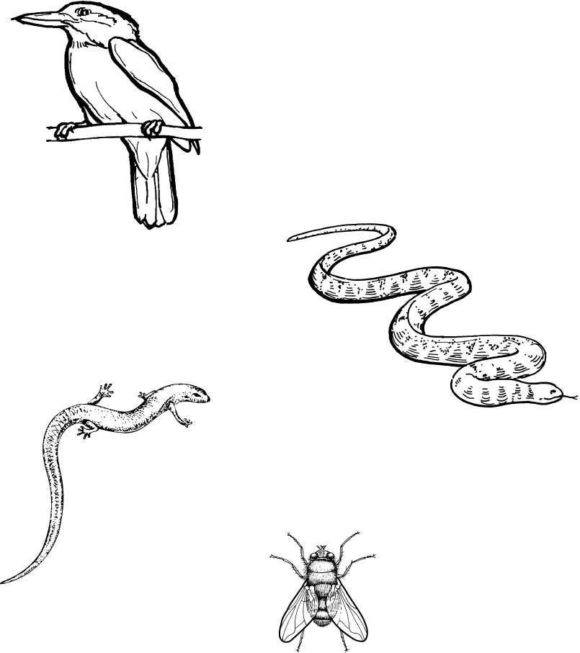
a Why is a food web a more accurate representation than a food chain?
__________________________________________________________________________
__________________________________________________________________________
__________________________________________________________________________
__________________________________________________________________________

b Use arrows to make several connections in the food web below.
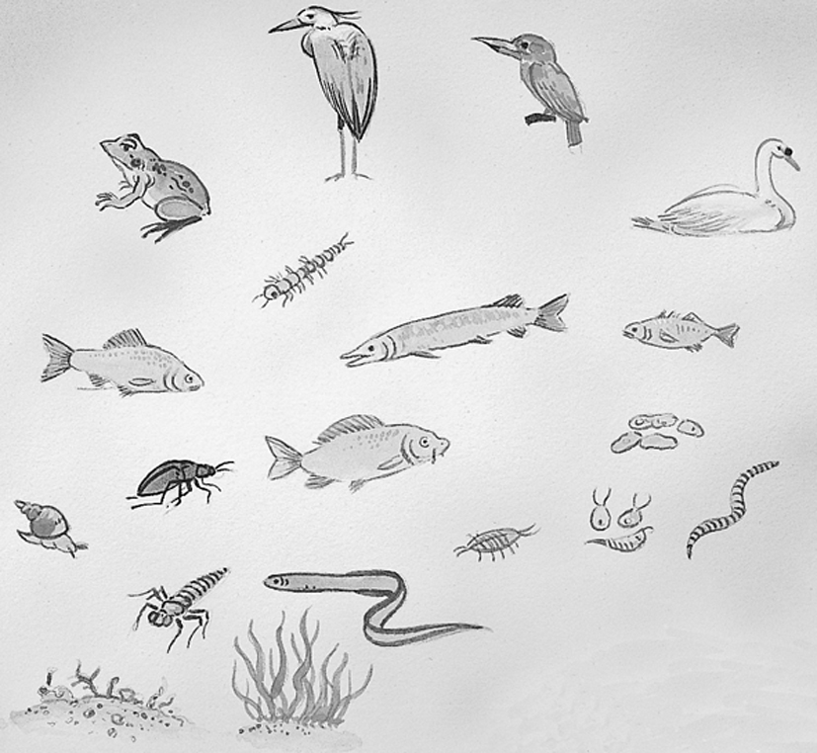

Find two of each in diagram above:

PRODUCER ORGANISMS __________________________ _______________________
FIRST ORDER CONSUMERS _______________________ ________________________
SECOND ORDER CONSUMERS ______________________ ______________________
TERTIARY ORDER CONSUMERS ____________________ _______________________

Choose one of the terms listed to describe each of the following interactions.
mutualism
competition
amensalism
herbivory
parasitism
predation
a A small bird picks insects from a rhinoceros’ hide.
________________________________________________

b Wallabies using a particular route repeatedly eventually wear a trail in the bush.
________________________________________________

c A tick burrows into the skin of a stumpy tail lizard, causing minor skin irritation.
________________________________________________

d A koala eats the leaves on a branch of a gum tree.
________________________________________________

a Use the graph below to estimate the human population in the year 2000.
________________________________________________________
b What range of values do you think the population will lie between in the year 2020?
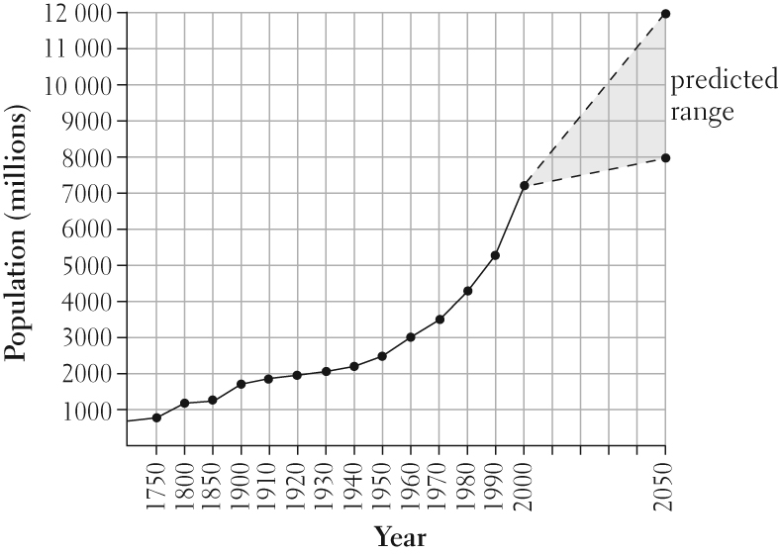
________________________________________________________________________________________________________________
List four types of waterway and ocean pollution.
___________________________________________________________

___________________________________________________________

___________________________________________________________

___________________________________________________________
Describe the cause of two of the types of pollution in the previous question.
Pollution:

___________________________________________________________

___________________________________________________________
Give two examples of problems caused by introduced species.
___________________________________________________________

___________________________________________________________
Suggest two ways of encouraging conservation of our native plants and animals.
___________________________________________________________

___________________________________________________________

